Sell :POLARIS |  |  | Al ALBAB COMPANY FOR GENERAL CONTRACTING LTD
Attn: | IRAQ – BAGHDAD – JURF AL NADAF  POLARISSTEEL100@GMAIL.COM  +9647702785648  OMER ALI | Offer: By Email | Mr Ammar J.  Tel: +964 7704007200  E-mail: info@albab.com.iq: cfo@albab.com.iq;log@albab.com.iq

# | Details | Dimensions | Quantity | Duration | Price per Unit | Total Price
1 | 50m³ Diesel Storage Tank | D 3000 L 7500 | 4 | Last Tank Received: 60 working days.  Upcoming Deliveries:  - First Delivery: One 50 m³ diesel tank and one daily tank 15 working days.  - Subsequent Deliveries: Every 15 working days, a new tank should be received periodically. | 16,000,000 IQD | 64,000,000 IQD
2 | 5M³ Diesel storage tank- daily tank | D 1500 L 3000 | 4 |  | 5,000,000 IQD | 20,000,000 IQD
3 | 20m3 Diesel Storage Tank | D 2100 L 6000 | 1 |  | 11,000,000 IQD | 11,000,000 IQD
 | Total |  |  |  |  | 95,000,000 IQD
Discount |  |  |  |  |  | 5,000,000 IQD
Net Price CIP Site of work in EBS AL NAHRWAN AREA. |  |  |  |  |  | 90,000,000 IQD

Technical Specification:
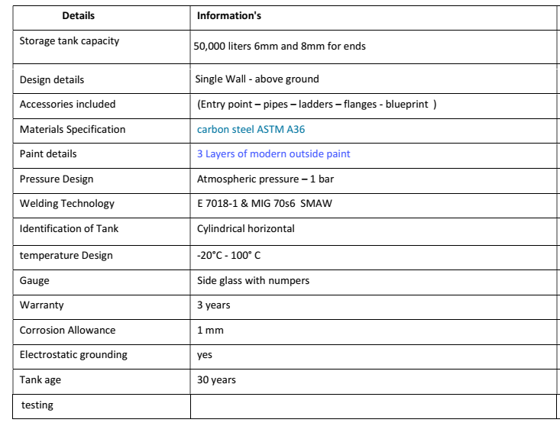
Note: -
- The invoice will be based on packing.
- The PO is subject to the terms & conditions stated.
- PO’s pages must be signed and stamped by both parties.
- Products should guarantee from defects
- All the data sheet and specification should comply with attached approval data and specifications

Payment:
- 33.34% advanced payment
- 20% after Materials arrived and accepted by EBS
- 10 % after complete assembly the tanks
- 36.66% after receive the test result and accepted by EBS

DELIVERY SCHEDULE:
- Last Tank Received: 40 days ago.
  - Upcoming Deliveries:
    - First Delivery: One 50 m³ diesel tank and one daily tank (expected within 2 weeks).
    - Subsequent Deliveries: Every 10 days, a new tank should be received periodically.

PACKING:
The goods should delivery site of work safely with no any damage

Document required:
- Welding procedure
- Methot statement
- Acceptance test result
- Acceptance inspection test

EFFECTIVE DATE (THE EFFECTIVE DATE)
- From of the date of signature of PO by both parties.
- The Delivery form down payment receiving

INLAND TRANSPORT AND INSURANCE
The Seller shall insure all the Goods under this Purchase Order to be delivered safely and completely to the Carrie nominated by the Buyer in due time with no damage and losses. The Seller shall bear at his own risk and expenses all damage and losses caused in any cases before delivery. The Seller shall bear the expenses of inland carriage and insurance before delivery.

WARRANTIES
The Warranty Period for the goods under the Purchase 0rderrshall be 18 months from the date of delivery of goods to the carrier, or 12 months from the date of Check and Acceptance Certificate signed by the representatives of the two Parties after the goods being checked and or inspected and or tested to be confirmed their conformity to the Purchase Order by the Buyer's representative(s)on jobsite, whichever period shall first expire.

force majeure

The Seller shall not be held responsible for the delay in shipment or non-delivery of the Goods due to Force Majeure such as war, serious fire, flood, typhoon and earthquakes or other events agreed upon by both parties, which might occur during the process of manufacturing or in the course of loading or in transit. The Seller shall advise the Buyer immediately of the occurrence mentioned above.

ARBITRATION

Any dispute arising from or in connection with this Purchase Order shall be settled friendly through negotiations of the two Parties. In case no settlement can be reached, the dispute shall be submitted to Iraqi Arbitration Court in Baghdad which shall be conducted in accordance with Iraqi arbitration rules in effect at the time of applying for arbitration. The arbitral award is final and binding upon both parties. Arbitration fee shall be borne by the losing party. Location of Arbitration shall be in Baghdad, Republic of Iraq.

Sell: POLARIS | Al ALBAB COMPANY FOR GENERAL CONTRACTING LTD.
By Date: Signature: & Stamped: | By Date: Signature: & Stamped:

